INTRODUCTION

The project, **Online shopping,** caters to the working of an online shopping website. The application allows user to :

* Create profile
* View items add it in his/her cart
* Proceed to pay for the same
* Displays the details of the past orders.
* Registered users can update, delete item in their carts
* Tentative date of delivery and additional distance charges are calculated on the basis of the address entered by the user.

**Home**

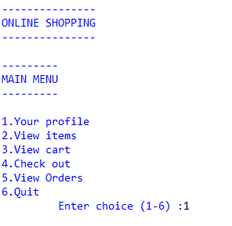

**User** **Profile**

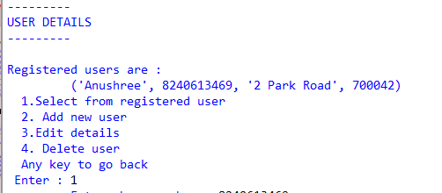

1.Displaying Items

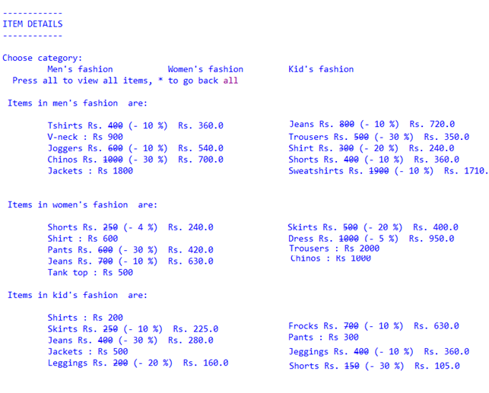

2.Sorting items

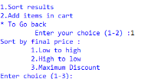

3.Addition to cart

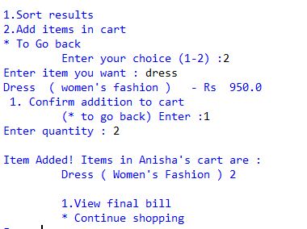

4.Check out

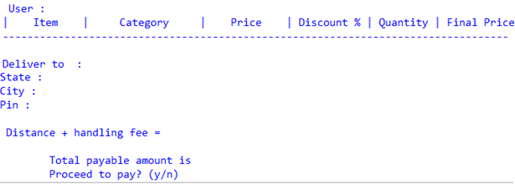

**Cart** **Details**

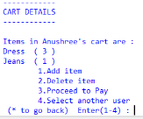

4.Check out

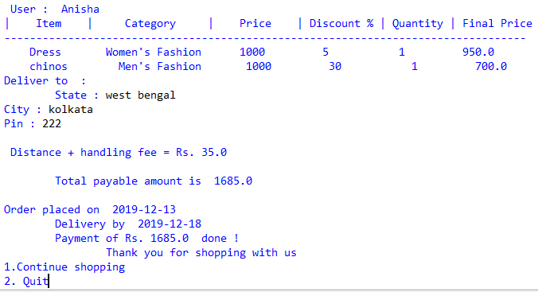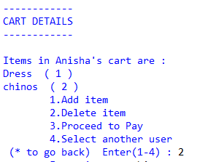

**Module** **6** **:** **View** **past** **orders**

